Hierarchical Graphics
Angel, Chapter 8. Red BOOK, chapter 7. Display Lists

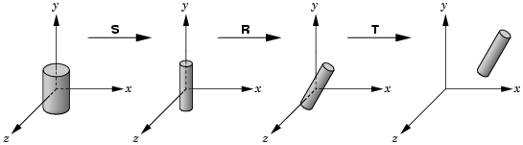
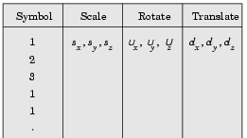
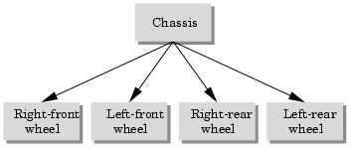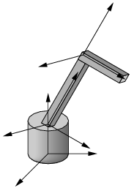

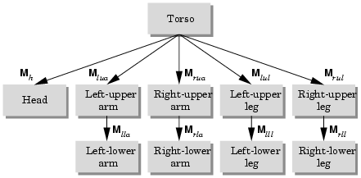

A Stack based traversal
Figure()
{
glPushMatrix();
torso();
glTranslate
glRotate
head();
glPopMatrix();

glPushMatrix();
glTranslate
glRotate
left_upper_leg();
glTranslate
glRotate
left_lower_leg();
glPopMatrix();

glPushMatrix();
glTranslate
glRotate
right_upper_leg();
glTranslate
glRotate
right_lower_leg();
glPopMatrix();

glPushMatrix();
…

Tree data Structures
Left-child right-sibling structure 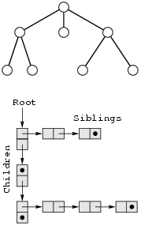

Typedef struct treenode
{
glfloat m[16];
void (*f)();
struct treenode *sibling;
struct treenode *child;
} treenode;

treenode torso_node, head_node, lua_niode,…;
glLoadIdentity();
glRotate( theta[0], 0,1,0);
glGetFloatv(GL_MODELVIEW_MATRIX, torso_node.m);

torso_node.f=torso;
torso_node.sibling = NULL;
torso_node.child = &head_node;

….

glLoadIdentity();
glTranslatef( -(TORSO_RADIUS+UPPER_ARM_RADIUS), 0.9*TORSO_HEGHT, 0);
glRotate( theta[3], 1,0,0);
glGetFloatv(GL_MODELVIEW_MATRIX, lua_node.m);
lua_node.f=left_upper_arm;
lua_node .sibling = & rua_node;
lua_node.child = & lla_node;

…

void traverse( treenode * root)
{
if( root ==NULL)
return;
glPushMatrix();
glMultMatrix(root->m);
root->f();
if(root->child != NULL) traverse (root -> child );
glPopMatrix();
if(root->sibling != NULL) traverse (root -> sibling );
}

see “figuretree.c”

Scene Graphs
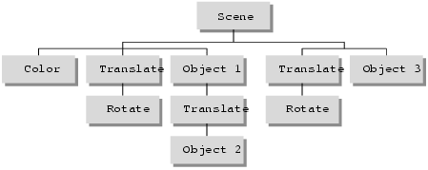

Display-List Design Philosophy
glNewList(1, GL_COMPILE);
draw_some_geometric_objects();
glEndList();

glLoadMatrix(M);
glCallList(1);
----------------------------------------------------------------------------

Creating and Executing a Display List
GLuint listName;

static void init (void)
{
listName = glGenLists (1);
glNewList (listName, GL_COMPILE);
glColor3f (1.0, 0.0, 0.0); /* current color red */
glBegin (GL_TRIANGLES);
glVertex2f (0.0, 0.0);
glVertex2f (1.0, 0.0);
glVertex2f (0.0, 1.0);
glEnd ();
glTranslatef (1.5, 0.0, 0.0); /* move position */
glEndList ();
glShadeModel (GL_FLAT);
}
void display(void)
{
GLuint i;

glClear (GL_COLOR_BUFFER_BIT);
glColor3f (0.0, 1.0, 0.0); /* current color green */
for (i = 0; i < 10; i++) /* draw 10 triangles */
glCallList (listName);
drawLine (); /* is this line green? NO! */
/* where is the line drawn? */
glFlush ();
}

The glTranslatef() routine in the display list alters the position of the next object to be drawn. Without it, calling the display list twice would just draw the triangle on top of itself.
Only one display list can be created at a time. In other words, you must eventually follow glNewList() with glEndList() to end the creation of a display list before starting another one.

Naming and Creating a Display List
GLuint glGenLists(GLsizei range);
Allocates range number of contiguous, previously unallocated display-list indices. The integer returned is the index that marks the beginning of a contiguous block of empty display-list indices. The returned indices are all marked as empty and used, so subsequent calls to glGenLists() don't return these indices until they're deleted. Zero is returned if the requested number of indices isn't available, or if range is zero.
In the following example, a single index is requested, and if it proves to be available, it's used to create a new display list:
listIndex = glGenLists(1);
if (listIndex != 0) {
glNewList(listIndex,GL_COMPILE);
...
glEndList();
}
Note: Zero is not a valid display-list index.
void glNewList (GLuint list, GLenum mode);
Specifies the start of a display list. OpenGL routines that are called subsequently (until glEndList() is called to end the display list) are stored in a display list, except for a few restricted OpenGL routines that can't be stored. (Those restricted routines are executed immediately, during the creation of the display list.) list is a nonzero positive integer that uniquely identifies the display list. The possible values for mode are GL_COMPILE and GL_COMPILE_AND_EXECUTE. Use GL_COMPILE if you don't want the OpenGL commands executed as they're placed in the display list; to cause the commands to be executed immediately as well as placed in the display list for later use, specify GL_COMPILE_AND_EXECUTE.
void glEndList (void);
Marks the end of a display list.
When a display list is created it is stored with the current OpenGL context. Thus, when the context is destroyed, the display list is also destroyed. Some windowing systems allow multiple contexts to share display lists. In this case, the display list is destroyed when the last context in the share group is destroyed.

Executing a Display List
After you've created a display list, you can execute it by calling glCallList(). Naturally, you can execute the same display list many times, and you can mix calls to execute display lists with calls to perform immediate-mode graphics, as you've already seen.
void glCallList (GLuint list);

Hierarchical Display Lists
You can create a hierarchical display list, which is a display list that executes another display list by calling glCallList() between a glNewList() and glEndList() pair. A hierarchical display list is useful for an object made of components, especially if some of those components are used more than once. For example, this is a display list that renders a bicycle by calling other display lists to render parts of the bicycle:
glNewList(listIndex,GL_COMPILE);
glCallList(handlebars);
glCallList(frame);
glTranslatef(1.0,0.0,0.0);
glCallList(wheel);
glTranslatef(3.0,0.0,0.0);
glCallList(wheel);
glEndList();
To avoid infinite recursion, there's a limit on the nesting level of display lists; the limit is at least 64

Managing Display List Indices
So far, we've recommended the use of glGenLists() to obtain unused display-list indices. If you insist upon avoiding glGenLists(), then be sure to use glIsList() to determine whether a specific index is in use.
GLboolean glIsList(GLuint list);
Returns GL_TRUE if list is already used for a display list and GL_FALSE otherwise.
You can explicitly delete a specific display list or a contiguous range of lists with glDeleteLists(). Using glDeleteLists() makes those indices available again.
void glDeleteLists(GLuint list, GLsizei range);
Deletes range display lists, starting at the index specified by list. An attempt to delete a list that has never been created is ignored.

Encapsulating Mode Changes
You can use display lists to organize and store groups of commands to change various modes or set various parameters. When you want to switch from one group of settings to another, using display lists might be more efficient than making the calls directly, since the settings might be cached in a format that matches the requirements of your graphics system.
Display lists may be more efficient than immediate mode for switching among various lighting, lighting-model, and material-parameter settings. You might also use display lists for stipple patterns, fog parameters, and clipping-plane equations. In general, you'll find that executing display lists is at least as fast as making the relevant calls directly, but remember that some overhead is involved in jumping to a display list.

